**DBMS LAB**

**ASSIGNMENT-6**

**SNEHA SINGH**

**20198023**

**IT 5 B2**

**Q.1) Write the SQL queries for the following with respect to database created: –**

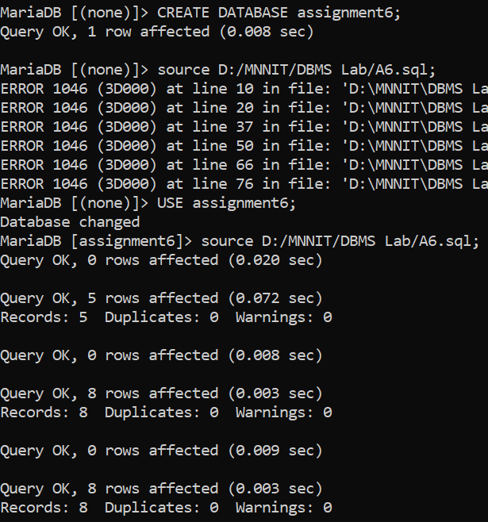

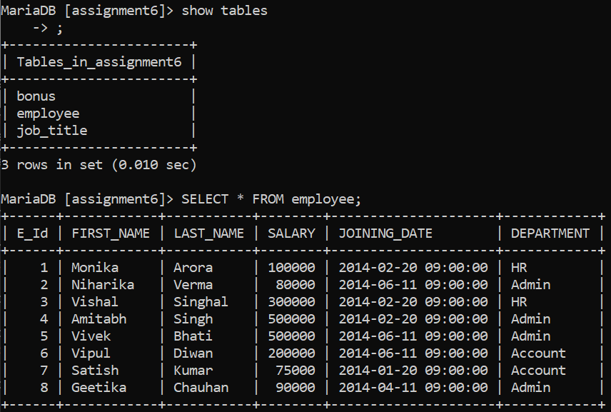

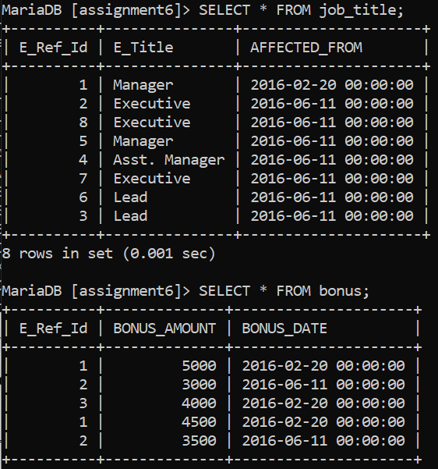

**a)Fetch first name of worker using alias name as E_Name.**

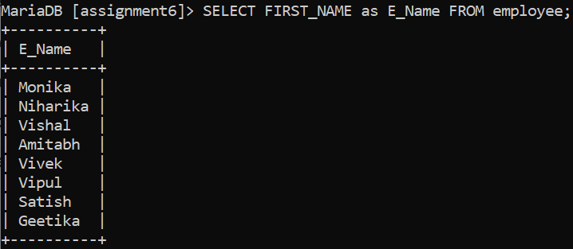

**b)List the last name of employees in upper case.**

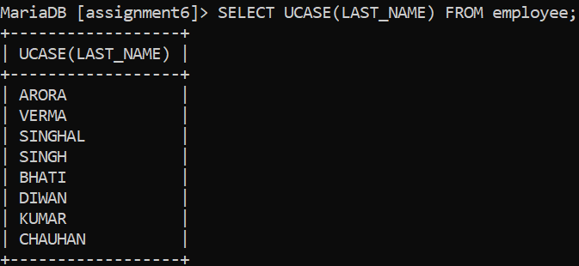

**c)Retrieve the first three characters of employees from their first name.**

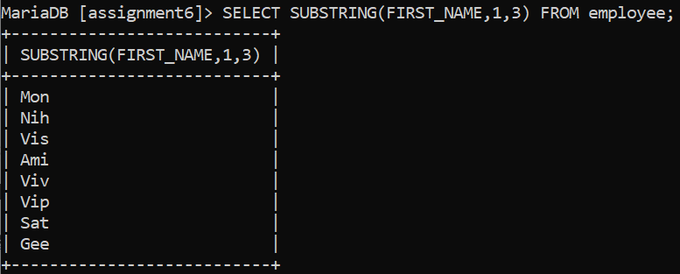

**d)Retrieve the unique values of department and display its length.**

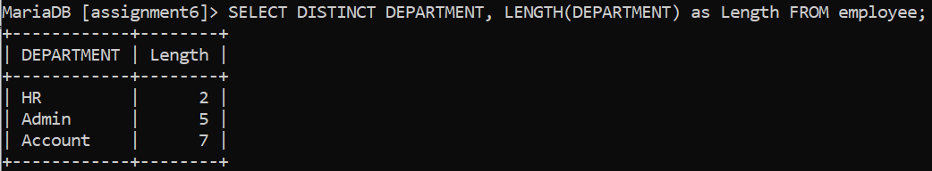

**e)List the first name from employees table after replacing ‘a’ with ‘A’.**

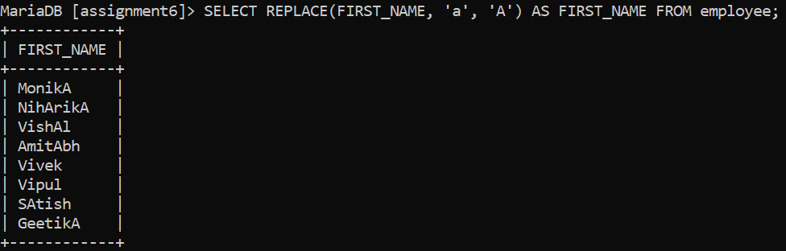

**f)Display all worker details, use order by in first name asc and department in desc.**

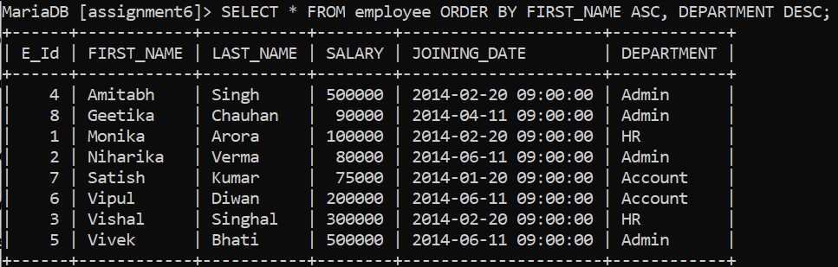

**g)List the details of an employee whose first name ends with ‘h’ and contains six alphabets.**

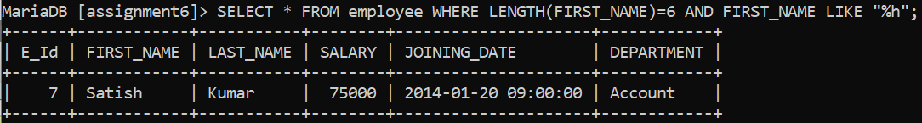

**h)Display the details of employees who have joined in Feb 2014.**

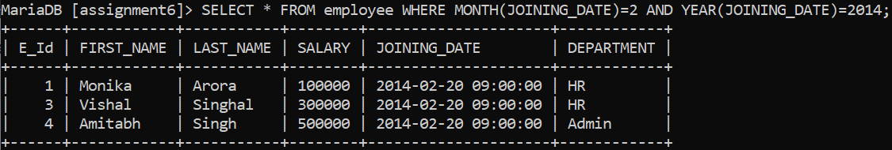

**i)Fetch the employee’s names with salaries over and equal to 50000 and less than equal to 100000.**

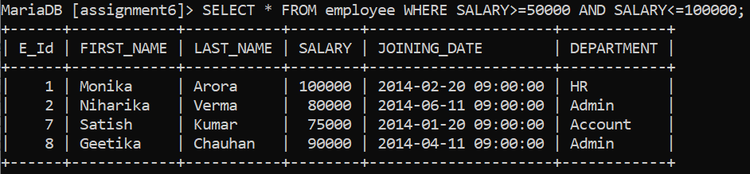

**j)List the no. of employees for each department in desc order.**

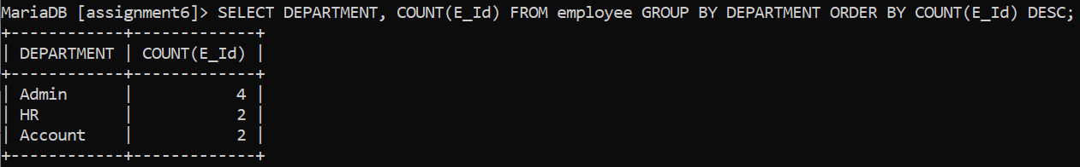

**k)Print the details of employees who are also managers.**

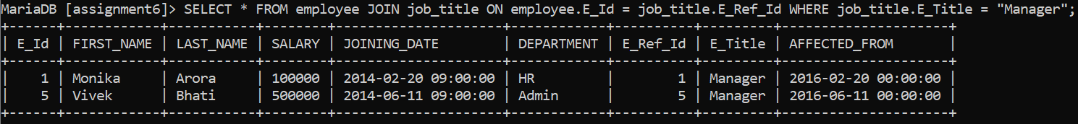

**l)Fetch the duplicate records having matching data in some fields of a table.**

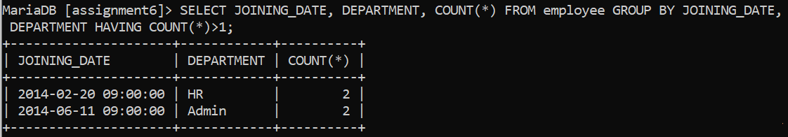

**m)Fetch intersecting records of two tables.**

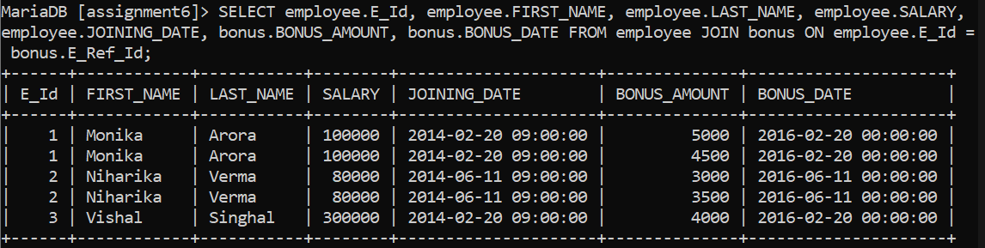

**n)Find the nth (say n=5) highest salary from a table.**

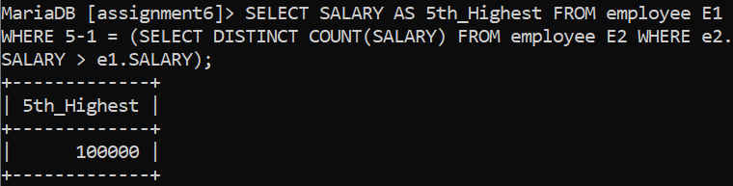

**o)Find the 4th highest salary without using TOP or limit method.**

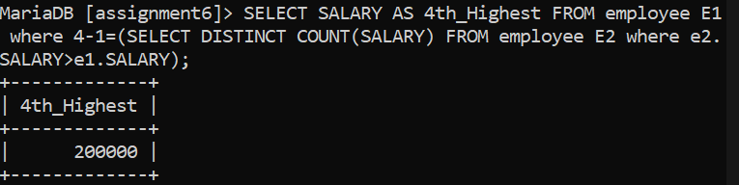

**p)List the details of employees with the same salary.**

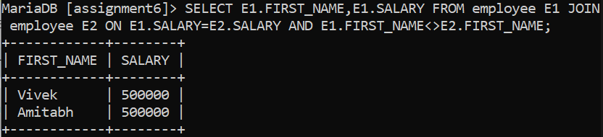

**q)Display the second highest salary from a table.**

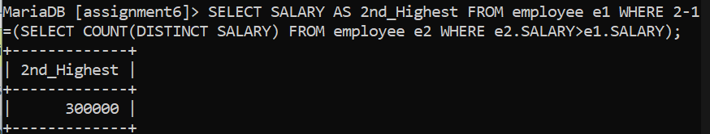

**r)Display all departments along with the number of people in there.**

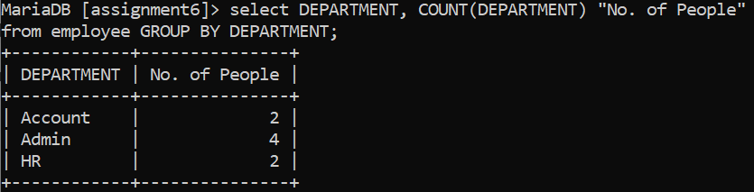

**s)List the name of employees having the highest salary in each department.**

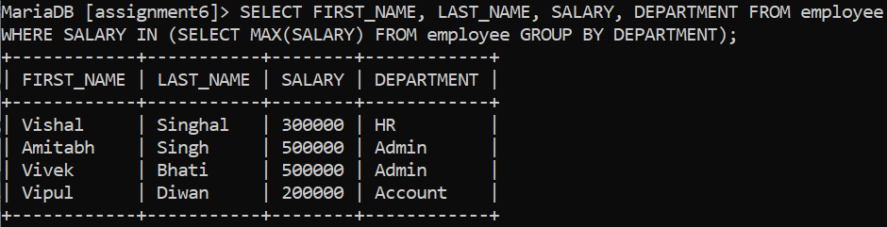

**t)Fetch three min salaries from a table**

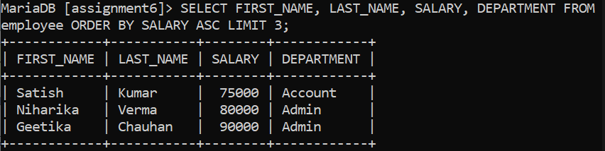

**u)Fetch departments along with the total salaries paid for each of them.**

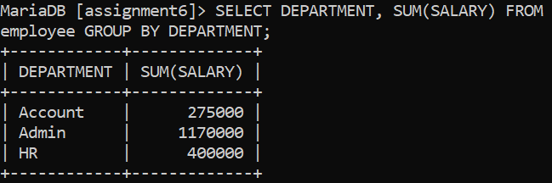

**v)Fetch the names of employees who earn the highest salary.**

